|  |  |
| --- | --- |
| **Databases**  Diploma in IT / FI / CSF  Year 1 (2019/20) Semester 2 | Week 4 |
| **2** hours |
| **PRACTICAL 4**  **SELECT (Part 4)** | |

**OBJECTIVES**

At the end of this practical, you should know how to:

* construct SELECT statement that involved more than one table

**REFERENCES**

Please refer to the following appendices in Database textbook.

* Appendix B: Tables in *NP40 Book Rental System*’s Database
* Appendix E: Data Dictionary for *NP40 Book Rental System*
* MeL: Reference 1 – Relational Theory.ppt, Slides 15-19
* Database Textbook: pages 2-49 to 2-51, 2-54 to 2-55 and 2-56 to 2-58
* PolyMall: Database Systems - Topic 5 Join

[5.1 Join Tables](https://polymall.polytechnic.edu.sg/webapps/scor-scormengine-BB5784d4c32fccb/delivery?action=launchPackage&course_id=_813_1&content_id=_36378_1)

**QUESTIONS**

Syntax:

**SELECT [ ALL | DISTINCT ] { \***

**| { table_name | table_alias }.\***

**| { column_name | express } [ [ AS ] column_alias ]**

**| column_alias = expression**

**} [ , … n ]**

**FROM table_name1 [ [ AS ] table_alias ]**

**[ INNER JOIN** **table_name2** **ON** *table_name1.field1* = *table_name2.field2* **]**

**[ INNER JOIN** **table_name3** **ON** *table_name2.field2* = *table_name3.field3* **]**

**[ INNER JOIN** **table_namex** **ON** *table_name3.field3* = *table_namex.fieldx* **]**

**[ WHERE search_condition ]**

**[ ORDER BY { order_expression [ ASC | DESC ] } [ , … n ] ]**

Construct SQL statements for the following queries.

### Two-Table Join (Q1 – Q4)

1. List ISBN, CopyNo, Title and RentalRate for every book copy in *NP40 Book Rental*.

The following questions may help you in formulating the query.

* + Which table stores ISBN, CopyNo and RentalRate? What is the primary key and foreign key of that table?
  + Which table stores the Title of book? What is the primary key of that table?

You have to join these two tables that you have identified.

**Hint: use INNER JOIN and ON**

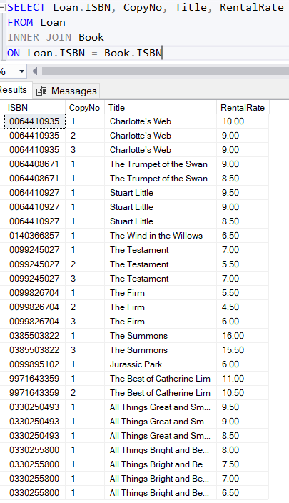

1. List the ISBN, Title and Category for all the books and display the results as shown below in ascending order of Title.

ISBN Title Category

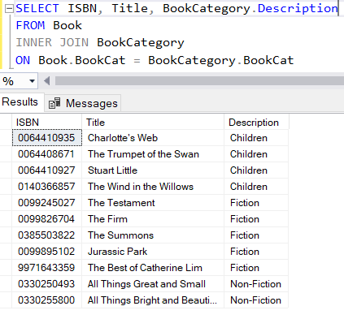

1. List the **'Manager’s Name'** for each of the branch and display the results as shown below:

BranchNo Address Manager’s Name

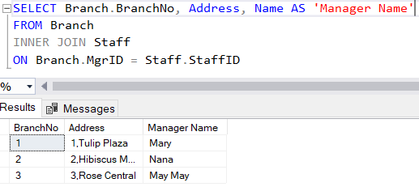

1. List the StaffID, Name and DateJoin for all the staff who work for supervisor 'May May'.

Staff ID Name DateJoin

### 

### Three-Table Join (Q5 – Q6)

1. List the ISBN, Title and DateOut for all the loans made by the member 'Kumar' and display the results in ascending order of DateOut.

ISBN Title DateOut

……….. ……….. ………..

**Hint: use more than one INNER JOIN**

6. List the ISBN, Title and Author for all the books and display the results in ascending order of Title.

ISBN Title Author

……….. ……….. ………..

7. List the number of loan made and total rental rate paid by Jeremy Law.

Number of Loan Total Rental Rate

……….. ………..

8. List the names of all the supervisors in alphabetical order. If the supervisor has more than one staff, his name should appear only once.

9. List the ISBN, Title and YearPublish for all the **'Fiction'** books published by publisher named **'Arrow Books'** and display the results in ascending order of YearPublish.

ISBN Title YearPublish

……….. ……….. ………..

10. List the StaffID, Name, DateJoin and number of years of service for all the staff that have been with the *NP Book Store* for less than 10 years and who worked for the supervisor 'May May'.

Staff ID Name DateJoin Years In Service

……….. ……….. ……….. ………..

### Optional

11. List the LoanNo, ISBN, Name of members, DateOut, RentalRate of all the loans.

LoanNo ISBN Name DateOut RentalRate

……….. ……….. ……….. ……….. ………..

(The following questions may help you in formulating the query.

* Which table identifies the details of loans? What is the primary and foreign key of that table?
  + Which table stores the name of the member? What is the primary key of that table?

*Note : You have to join these two tables that you have identified.*

12. List the ISBN, CopyNo and DateOut for all the loans made on the book titled **'Stuart Little'**.

ISBN CopyNo DateOut

……….. ……….. ………..

**Hint: use WHERE**

13. List the ISBN, Title and YearPublish for all the books published by the publisher 'Pan Books'.

ISBN Title Year Publish

……….. ……….. ………..

14. List the MemberID, Name of members, DateDue and DateReturn for loan that was returned late and display the results in descending order of DateReturn.

MemberID Name DateDue DateReturn

……….. ……….. ……….. ………..